*Submit this report to your funding agency.* ***It should not be submitted to the North Carolina Arts Council.***

# Organization Information

Name of Organization _________________________________________________________________

Contact Person’s Name________________________________________________________________

Contact Person’s Title _________________________________________________________________

Mailing Address _____________________________ City _____________________________________

State: North Carolina Zip Code _________________ County________________________________

Work Phone (___) ______________________ Fax Number (___) _____________________________

E-mail Address _______________________________________________________________________

Website _____________________________________________________________________________

Organization’s EIN_____________________________________________________________________

Organization’s UEI_____________________________________________________________________

Applicant Race________________________________________________________________________

Please give a brief description of your organization, including mission, board and staff composition, current arts programs and services and number and kinds of people served. Public schools and other large governmental or community agencies should provide a description of their arts program only rather than the entire organization.

BAC

Grassroots Arts

Program Subgrant

Application FY 2024-2025

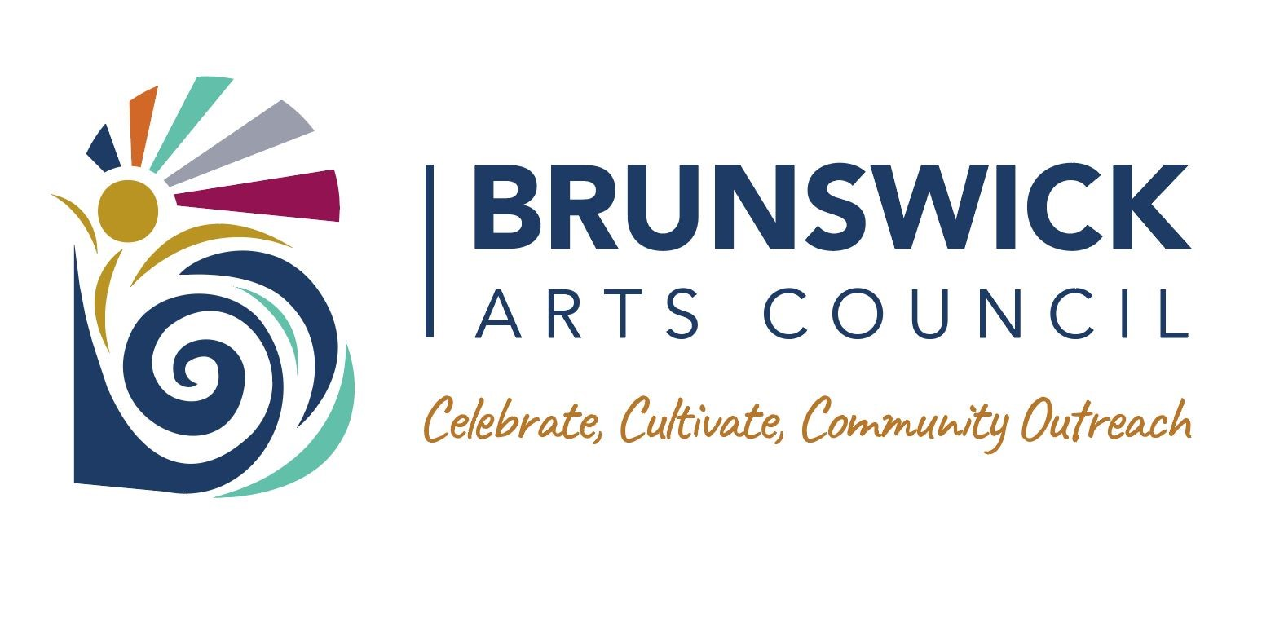

**Organizational Finances:**

Please attach complete income and expense statement (an audit may be substituted) for your last fiscal year and complete operating budgets for the current fiscal year and next fiscal year. Public schools and other large governmental or community agencies should attach arts program financial information only. Please copy the totals from these attachments in the spaces below.

Last Year Actual FY ____________ Current Year FY ___________ Next Year FY ____________

Actual Income $ ____________ Income $ ____________ Projected Income $ ____________

Actual Expenses $ ____________ Expenses $ ____________ Projected Expenses $ ___________

# Project Description

**Grant Amount Requested**: __________________

**Project Start Date**: ________________________ (No earlier than July 2024) **Project End Date**: _________________________ (No later than June 15, 2025)

**Project Narrative:**

Please attach a narrative providing the information requested below for the project you propose. Please be concise and specific as possible:

1. Project title or summary description
2. Project goals
3. Description of intended participants/audience, including estimated numbers and racial and cultural composition
4. Location where project will take place
5. Description of project activities

BAC

Grassroots Arts Program

Subgrant Application Form

FY 2024-2025



1. Description of the artists to be involved in the project, how and why they were chosen and, if appropriate, the rate of payment for their services (If you have not yet selected the artists, describe the kinds of artists you intend to involve and how you will select them.)
2. Description of how the project will be publicized and promoted to reach intended participants 8. Description of how you will evaluate the project

35

Please provide a projected budget for your proposed project utilizing the format below.

**Project**

**Budget**

**:**

BAC

Grassroots Arts Program

Subgrant Application Form

FY 2024-2025



|  |  |  |  |  |  |  |
| --- | --- | --- | --- | --- | --- | --- |
| **Project Expenses**  **A. Personnel** | | Cash Expenses | = | Grant Amount Requested | + | Applicant Cash Match |
| 1. Administrative Staff | | ____________ |  | ____________ |  | ____________ |
| 2. Artistic Staff | | ____________ |  | ____________ |  | ____________ |
| 3. Technical/Production Staff **B. Outside Fees and Services** | | ____________ |  | ____________ |  | ____________ |
| 1. Artistic Contracts | | ____________ |  | ____________ |  | ____________ |
| 2. Other Contracts  _________________ | | ____________ |  | ____________ |  | ____________ |
| **C. Space Rental** | | ____________ |  | ____________ |  | ____________ |
| **D. Travel** | | ____________ |  | ____________ |  | ____________ |
| **E. Marketing** | | ____________ |  | ____________ |  | ____________ |
| **F. Remaining Project Expenses** | | ____________ |  | ____________ |  | ____________ |
| **G. Total Cash Expenses**  **Project Income** | | ____________ = |  | ____________ | + | ____________ |
| **A.** | **Admissions** | ____________ |  |  |  |  |
| **B.** | **Contracted Services Revenue** | ____________ |  |  |  |  |
| **C.** | **Other Revenue** | ____________ |  |  |  |  |
| **D.** | **Private Support** |  |  |  |  |  |
|  | 1. Corporate Support | ____________ |  |  |  |  |
|  | 2. Foundation Support | ____________ |  |  |  |  |
|  | 3. Other Private Support | ____________ |  |  |  |  |
| **E.** | **Government Support** |  |  |  |  |  |
|  | 1. Federal | ____________ |  |  |  |  |
|  | 2. State/Regional | ____________ |  |  |  |  |
|  | 3. Local | ____________ |  |  |  |  |
| **F.** | **Applicant Cash** | ____________ |  |  |  |  |
| **G.** | **Grant Amount Requested in this application** | ____________ |  |  |  |  |
| **H.** | **Total Cash Income (Must at least equal Total Cash Expenses, Item G above)** | ____________ |  |  |  |  |

**Certification**

BAC

Grassroots Arts Program

Subgrant Application Form

FY 2024-2025



We understand that failure to respond to any of the above items may adversely affect the consideration of this application. We certify that we are committed to the completion of the proposed project in compliance with legal requirements and granting procedures. We certify that the information contained in this application, including attachments and supporting materials, is true and correct to the best of our knowledge.

Name and Position of Authorizing Official ______________________________________________________ Signature of Authorizing Official ________________________________________ Date ________________

Signature of Contact Person ____________________________________________ Date ________________

# Guidelines for Grassroots Arts Program Subgrants

Since 1977, the N.C. Arts Council’s Grassroots Arts Program has provided North Carolina citizens access to quality arts experiences. The program distributes funds for the arts in all 100 counties of the state primarily through partnerships with local arts councils.

## Eligibility for Application

* All organizations must have been in operation for at least one year. While nonprofit 501(c)(3) status is preferred, organizations that are nonprofit in nature may also apply.
* All organizations must reside and carry out projects within the county they are applying for funds.
* Individuals are not eligible to apply for Grassroots Arts funds.
* Applications and support materials must be completed and received by the due date.
* All projects must take place between July 1, 2024 and June 15, 2025.
* Grant amounts range from $500 and up.

## What the Grassroots Arts Program Funds

Grassroots Arts Program funds may be used for expenditures to conduct quality arts programs or operate an arts organization. Typical uses of Grassroots money include:

* Program expenses such as professional artists’ fees and travel, space rental, advertising, marketing and publicity, Web site and electronic media, scripts, costumes, sets, props, music and equipment rental.
* Operating expenses for qualified arts organizations not already receiving operating support from the N.C. Arts Council. These can include salaries, telephone, office supplies, printing, postage, rent, utilities, insurance and equipment rental.

## Priorities for Funding

The first priority of the Grassroots Arts subgrant program is to provide operating or program support to qualified arts organizations not already receiving or eligible to receive support from the N.C. Arts Council. These include theaters, symphonies, galleries, art guilds, choral societies, dance companies, folk arts societies, writers’ groups and arts festivals, among others.

The second priority of the Grassroots Arts subgrant program is to support arts learning and arts in education programs conducted by qualified artists. These can be artist residencies in schools, afterschool or summer camps or adult arts learning classes.

The third priority of Grassroots Arts subgrants is to community, civic and municipal organizations. These programs must be conducted by qualified artists.

## Funding Policies

* Tribal organizations that receive Grassroots funds must represent state or federally recognized tribes.
* Colleges, universities and libraries may receive grants for arts programs that are community-based or generate regional arts involvement. Grants may not support their internal programs, administration or operation expenses (library books, band boosters, equipment purchases).
* Grassroots funds may not be awarded to individuals or to organizations for prizes, competitions, tuition, or financial rewards.
* Grassroots funds may not be used for art supplies or equipment.
* Religious organizations or churches may not receive Grassroots funds unless the programs are presented outside regular church services, engage the larger community and do not contain religious content.
* Grassroots funds may not be used for activities associated with a school’s internal arts programs such as in-school student performances, the purchase of art supplies, or student arts competitions and publications.
* Municipalities (city/county governments) may receive grants for arts programs which use qualified artists to conduct programs that involve the greater community. Grants may not support internal programs, administration or operating expenses.

Grassroots Arts Program money may not be used for the following kinds of expenditures:

* Art, music, and dance therapists
* Artifacts
* Purchase artwork
* Purchase equipment or art supplies
* Capital expenditures or equipment

•Contingency funds

* Deficit reduction
* Fundraising events
* Food or beverages for hospitality or entertainment functions
* School band activities or equipment
* School choral activities

•Lobbying expenses

* Oral history and history projects
* Tuition for academic study
* Interest on loans, fines, or litigation costs

# Grassroots Arts Program Subgrant Requirements

## Matching Requirement

All subgrantees must match their grant amounts dollar for dollar. The funds must come from other public or private sources. Other N.C. Arts Council funds cannot be used as a match.

## North Carolina Arts Council Recognition

Subgrantees must acknowledge the N.C. Arts Council’s support of their event or projects by including the N.C. Arts Council’s logo, and funding credit line in all print and promotional materials related to the grant. The N.C. Arts Council’s website offers information and downloadable logos at [www.ncarts.org/grants-resources/resources/logo-branding-materials](https://www.ncarts.org/grants-resources/resources/logo-branding-materials)

### Brunswick Arts Council Recognition

Subgrantees must acknowledge the Brunswick Arts Council’s support of their event or projects by including the Brunswick Arts Council’s logo, and funding credit line in all print and promotional materials related to the grant. The Brunswick Arts Council’s website offers information and downloadable logos at https://brunswickartscouncil.org/grassroots-grants/ [#tab-1594305977703-3-1](https://www.ncarts.org/grants-resources/resources/organizations/local-arts-council-resources)

## Reporting Requirements

Each subgrantee is required to submit a final report providing a detailed description of the funded project, participation statistics and demographics, sample marketing and program materials using the N.C. Arts Council credit line and logo, and copies of their legislative letters.

The Subgrant Report form can be downloaded from the N.C. Arts Council Web site at:

[www.ncarts.org/grants-resources/resources/organizations/local-arts-council-resources. Look for **FY 2024-25**](http://www.ncarts.org/grants-resources/resources/organizations/local-arts-council-resources.%20Look%20for%20FY%202024-25) **final report for Grassroots Subgrantees.** Subgrant Report Forms should be submitted to the funding agency by June 30th.

## Legislative Letters

Applicants may be required to write their state representatives to thank them for appropriating Grassroots funds. If required, the letter should provide information about how

Grassroots funds were used to support your program or project, and the community impact of • Artistic quality of proposed project or programs the event. A copy of all letters to legislators must be included in the final report materials. • Community impact of project or programs

• Ability to plan and implement project

### How Subgrant Applications Are Evaluated• Stability and fiscal responsibility of the organization

Subgrant applications are reviewed by a diverse panel of community members including artists, county and public officials and arts council board members among others. The panel evaluates each application based on the subgrant guidelines and the following criteria:

Panelists discuss and score the grant using an established rating system. The subgrant panel’s funding decisions are then presented as recommendations to the Arts Council board of directors. The board of directors votes and gives final approval to the subgrant panel’s recommendations.

## Questions and Assistance

If applicants have questions or need assistance, please contact :

Mary Beth Livers

Executive Director Brunswick Arts Council execdir.brunswickartscouncil@gmail.com

910.448.2713 BAC cell

910.448.1016 personal cell

