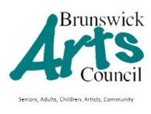
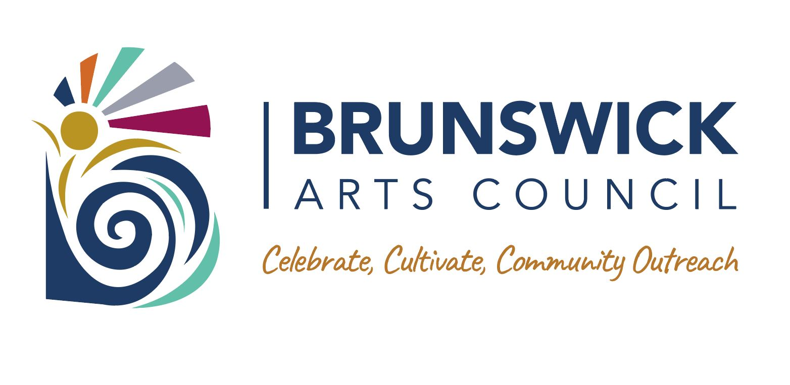
With
- Friends of Oak Island Parks
- Southport Evening Rotary
- The SoundHouse
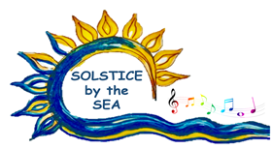
FESTIVAL VENDOR
APPLICATION FORM
June 19, 2021
10:00-8:00 PM
Vendor Set up 7 AM -9:30 PM
Middleton Park 46th & Dolphin St. Oak Island NC 28465

Name:___________________________________________________________________

Business or Organization Name (if applicable): _____________________________________________________

Address:_____________________________________________ City/State/Zip:_________________________

Primary phone:__________________________________ Phone # 2: ________________________________

Email:__________________________________________________________@________________________

NC Department of Revenue Account ID No. [9-digit no. (usually starts with 600)]_________________________

Description of Art, Products to sell or Community Group Promotion:

Celebrating the Arts in Brunswick!
- Complete & Sign application.
- Include photo/description of products
- Make a photocopy for your records
- Enclosed check or money order made payable to: Brunswick Arts Council
- Mail to:
Brunswick Arts Council
Attention: Solstice Festival
PO Box 6275
Ocean Isle, NC, 28469
- Enclose a self-addressed, stamped, #10 business-size envelope for return of map and booth assignment
- Email: Mary Beth Livers at execdir.brunswickartscouncil@ gmail.com

.

VENDOR FEES:

$ 40 | 10x10 vendor space
$ 25 | 10x10 vendor space BAC Member
$ 80 | 10x20 vendor space
$ 50 | 10x20 vendor space BAC member
$ 0 | Community Non-Profit BAC Partner
$ | Enter BAC Membership level to join  (if desired)
 | Total amount due | $_____________

ANNUAL BAC MEMBERSHIP: (January 1- December 31)
$ 25 Individual
$ 40 Family (2 or more)
$ 50 Business / Non-profit Group/ Organization
$ 15 Employee or Affiliated Person of Member Group
I have enclosed a check in the amount of $__________________.

By my signature below, I indicate that I have read, understand, and will abide by the Festival Rules and Guidelines. I also agree that I am responsible for any loss or damage to my personal property and for personal injury during the course of the festival and release the Festival Committee, the Brunswick Arts Council, and the Town of Oak Island from any claims resulting from them. I agree to display my NC DOR Sales & Use Tax Certificate in my booth in accordance with state law.

____________________________________________________________Date__________________
Signature of Exhibitor

Oak Islands COVID -19 Market Operations

What we are doing:

- Vendor spaces will be spaced 10 feet apart from other vendors to allow social distancing.
- Two lanes will be marked on the field to make sure the flow of foot traffic through the market heads in one direction.
- Signage explaining social distance, 3 W’s and market procedures will be posted around the market
- Hand sanitizer stations will be set up around the market for patrons and vendors to use.
- Market management will be marking 6ft. spaces in front of vendor booths for customers to wait in line.

What we are asking vendors to do:
- Only one customer will be allowed in a vendor booth at one time to maintain social distance protocol.
- Vendors and customers are encouraged to wear face coverings/masks, if available.
- Vendors are encouraged to wear gloves and hand-sanitize after handling money and before handling additional product.
- Customers are encouraged to pre-order and pre-pay for items if possible to reduce time spent at the market and cut down on money handling.
- Vendors are encouraged to offer hand sanitizer at their booths.
- Vendors and Customers who are sick are asked to stay at home.
- Vendors who do not follow these procedures will be asked to leave market.

Town of Oak Island Parks & Recreation

